**Faculty of Business**

**Certificate in Information Technology**

IT5x70 Programming Logic



**Semester 1 – 2016**

**ABC Assignment01**

**Author:** Taylor Everett

**STU ID:** 21600252

**Date**: 2nd of June 2016

## Introduction

ABC Company is a marketing and software development company with a client that represents the gaming and entertainment industry. The client would like the ABC Company to start the second iteration of their Running Man application which involves a figure running across a screen that is able to be slowed down and increased by the user (the first iteration prototype will be available to students). This software application is being developed as a promotional campaign gimmick to encourage participants to register with their business which will then successfully link to a video once the user has registered their email address and contact number with the software application (anything to do with the video production is outside of the scope for this assignment).

## Business Rules

* 1. Upon starting the application, a figure moves across the screen from left to right
  2. Speed is able to be slowed and increased by the user.
  3. The application will include button functions for the player to start, pause and exit the game as well as slowing the game down and speeding the game up.
  4. The user is also able to enter their email address and telephone number details into the application.
  5. A “success” message is returned upon successfully submitting the details if all of the boxes are correctly entered.
  6. Whilst an “error” message is returned if partial details are entered.
  7. The software application is to use appropriate coding comments throughout the application.
  8. Camel-case naming conventions as a standard.
  9. Develop a black-box test plan for your application for valid and invalid data tests.
  10. Logo of ABC needs to be in the upper right corner of the application
  11. A=green B=blue C=yellow

## Logic Depiction Diagram

Load

Run

Scroll

click

Email

Close

Pause

Start

Speed

Confirm Msg

END

Stop animation

Start animation

Phone

Video

Faster

Slower

Submit

Error

Error

## Flow chart

Start

View options

Close/

other controls

Enter details

Wrong/ Right

Email/phone

Confirm msg

To video

 Close

Play with sprite

WrongError

## Wireframe

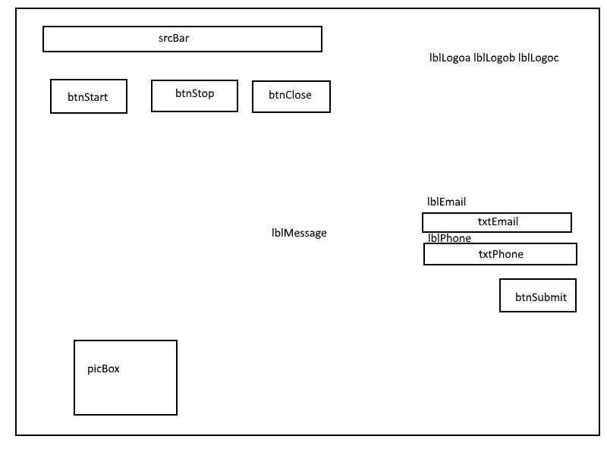

Message box

## Test Plan

ABC’s application will have two types of testing, White-box testing and Black-box testing results for the Black-box testing will be on this form. White-box testing is a method of testing software that test internal structures or working of an application, as opposed to its function. Black-box testing is a method of software testing that examines the functionality of an application without peering into its internal structures or workings.

## Black box Testing

|  |  |  |  |  |  |  |  |  |  |
| --- | --- | --- | --- | --- | --- | --- | --- | --- | --- |
| Test ID |  | Item | Test type | Input Data | Expected  result | Actual  Result | Pass/Fail | comment | Action |
| 1 | A | Running App | valid | Play app | App to open | Successful | pass | Opened | none |
| 1 | B | Does sprite play | valid | Play  app | Sprite runs across | Successful | pass | On open | none |
| 1 | C | Does  Sprite loop | valid | Play  app | Sprite run infinite | Successful | pass | On open | none |
| 2 | A | btnSubmit  no txt | invalid | none | No data  entered | Successful | pass | After clicking submit | none |
| 2 | B | txtPhone  submit/alone | invalid | One detail | Show  Error | Successful | pass | After clicking submit | none |
| 2 | C | txtEmail  submit/alone | invalid | One detail | Show  Error | Successful | pass | After clicking submit | none |
| 2 | D | txtEmail+  txtPhone+ submit | valid | Both details | Show  Confirm | Successful | pass | After clicking submit | none |
| 3 | A | Test 2A-2C  Message =  Error | invalid | Show  Error | Show in message box | Successful | pass | After clicking submit | none |
| 3 | B | Test 2D  Message =  Success | valid | Show  Succes | Show in message box | Successful | pass | After clicking submit | none |
| 4 | A | btnStop | valid | Click  Stop | Stops  The sprite from moving left to right | Successful | pass | Left click | none |
| 5 | A | btnStart | valid | Click  Start | Starts  The Sprite  Moving on its path again | Successful | pass | Left click | none |
| 6 | A | btnClose | valid | Click | Closes App | Successful | pass | Left click | none |
| 7 | A | scrBar right | valid | Drag right | Speed up  Sprite | Successful | pass | Left click and drag | none |
| 7 | B | scrBar left | valid | Drag  left | Slow down  Sprite | Successful | pass | Left click and drag | none |
|  |  |  |  |  |  |  |  |  |  |

## Recommendations

Add more animations to the sprite to have more effect when slowed and sped up. Add additional error information to the email and phone number if one is missing by highlighting the error in red. A loop has been added to app to extend play time with the sprite.

## Appendices

